**VISUALIZATION IN TIME SERIES ANALYSIS**

**Aim:**

To implement a program for visualization in time series analysis.

**Procedure & Code:**

**Step 1: Importing the required libraries**

import numpy as np

import pandas as pd

import matplotlib.pyplot as plt

import seaborn as sns

**Step 2: Loading and visualizing the dataset**

df=pd.read_csv("D:/tsa_107/data/Microsoft_Stock.csv")

print(df.describe())

df.head()

plt.figure(figsize=(10, 8))

plt.boxplot(df['Close'], vert=False)

plt.title('Box Plot of Microsoft Stock Closing Price')

plt.xlabel('Closing Price ($)')

plt.show()

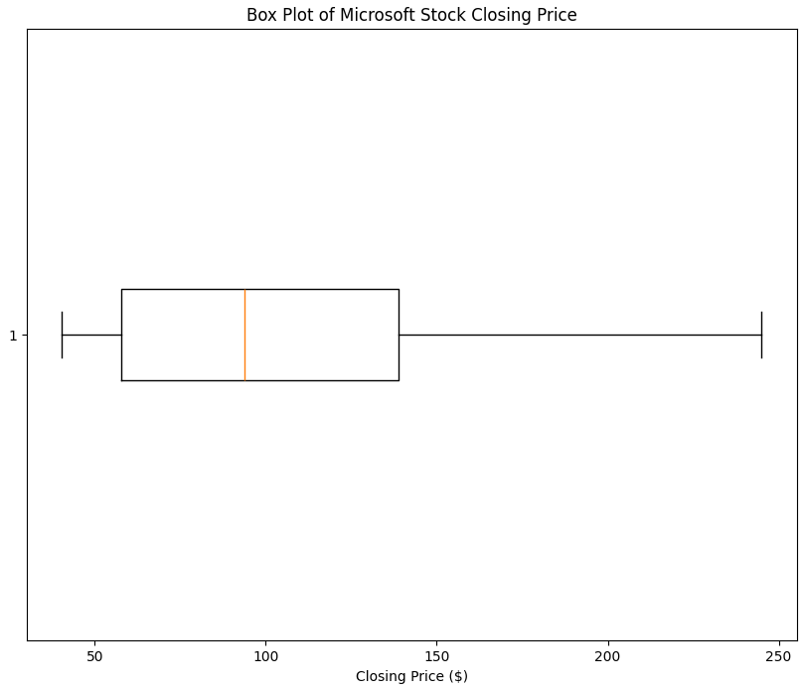

plt.figure(figsize=(8, 6))

plt.hist(df['Close'], bins=20, color='purple', edgecolor='black')

plt.title('Distribution of Microsoft Stock Closing Prices')

plt.xlabel('Closing Price ($)')

plt.ylabel('Frequency')

plt.grid(True)

plt.show()

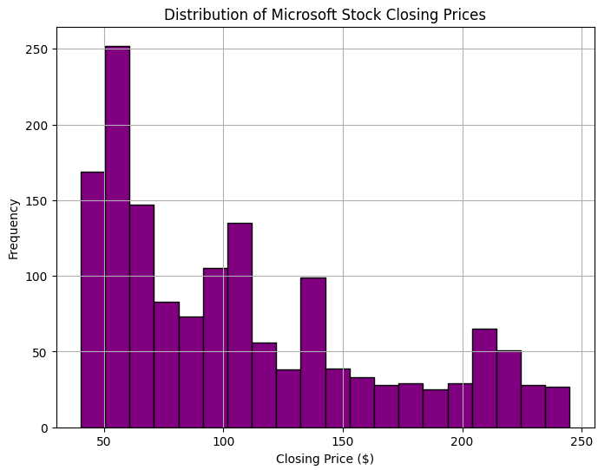

df_numeric = df.select_dtypes(include=[np.number])

plt.figure(figsize=(10, 6))

sns.heatmap(df_numeric.corr(), annot=True, cmap='coolwarm', linewidths=0.5)

plt.title('Correlation Heatmap of Stock Data')

plt.show()

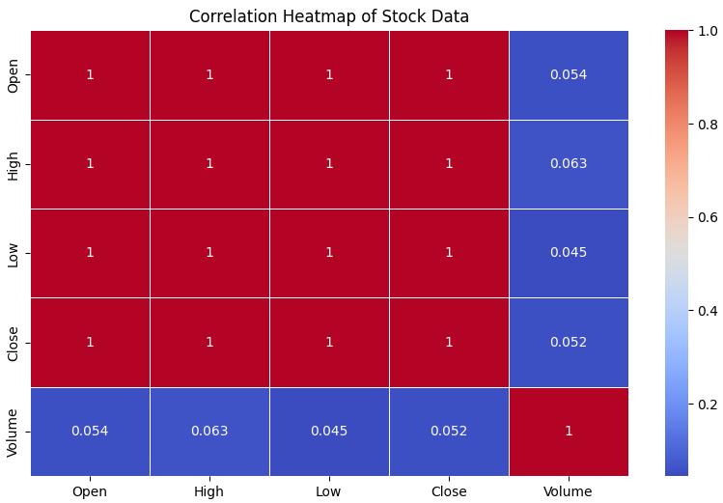

import matplotlib.dates as mdates

plt.figure(figsize=(12, 6))

plt.plot(df['Date'], df['Close'], color='blue')

plt.title('Stock Price Trend Over Time')

plt.xlabel('Date')

plt.ylabel('Closing Price ($)')

plt.xticks(rotation=45)

plt.gca().xaxis.set_major_locator(mdates.AutoDateLocator())

plt.grid(True)

plt.show()

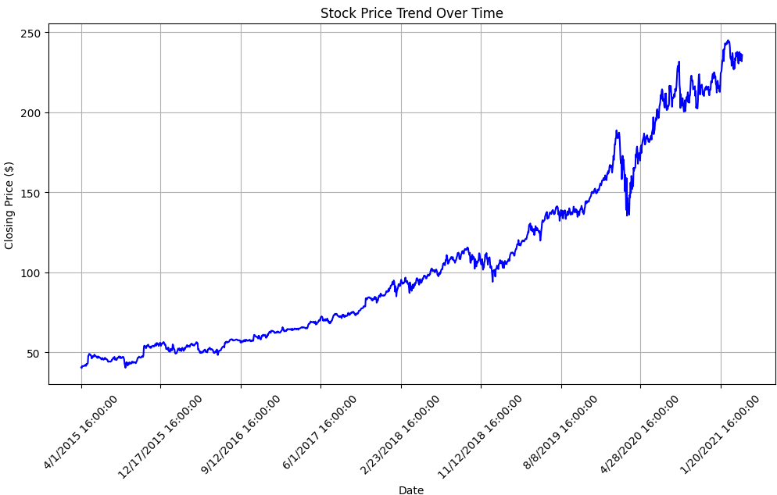

import networkx as nx

df_numeric = df.select_dtypes(include=[np.number])

corr_matrix = df_numeric.corr()

G = nx.Graph()

threshold = 0.5

for i in corr_matrix.columns:

for j in corr_matrix.columns:

if i != j and abs(corr_matrix.loc[i, j]) > threshold:

G.add_edge(i, j, weight=corr_matrix.loc[i, j])

plt.figure(figsize=(8, 6))

pos = nx.spring_layout(G)

nx.draw(G, pos, with_labels=True, node_color='skyblue', edge_color='gray', node_size=3000, font_size=10)

edge_labels = {(i, j): f"{corr_matrix.loc[i, j]:.2f}" for i, j in G.edges()}

nx.draw_networkx_edge_labels(G, pos, edge_labels=edge_labels)

plt.title("Feature Correlation Network Graph")

plt.show()

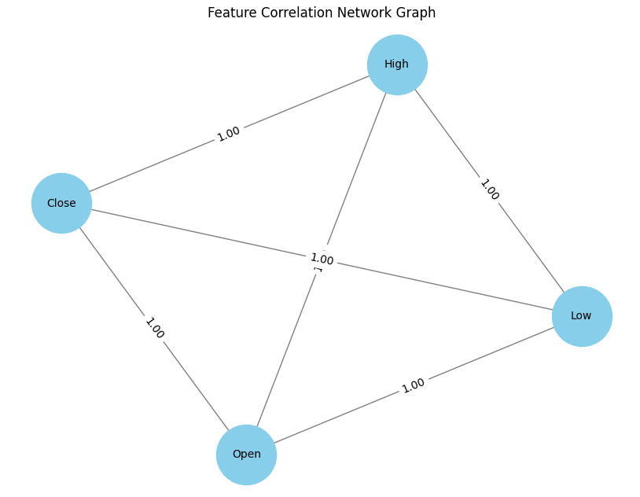

**Result:**

Thus the implementation of a program for time series data cleaning, loading, handling and preprocessing techniques has been successfully written and executed successfully.